Tiny File Manager Walkthrough

Requirements:

Nmap

Python, Netcat, and OpenSSL (Used in this walkthrough but are optional)

Difficulty:

Medium-High (Multiple steps)

Walkthrough:

1. Build and host the docker server.
   * docker build -t <NAME> .
   * docker run -p 80:80 <NAME>
2. Run NMAP to find the open port.

1. Navigating to the webserver on port 80 reveals a Tiny File Manager login portal.

1. Researching Tiny File Manager reveals numerous vulnerabilities. ExploitDB has one for version 2.4.6 the most recent vulnerable version currently.

1. Downloading and executing the exploit script using the suggested credentials results in a web shell.

1. Upgrading to a semi-interactive shell can be done using an uploaded PHP reverse shell. The reverse shell one-liner was found at <https://github.com/swisskyrepo/PayloadsAllTheThings/blob/master/Methodology%20and%20Resources/Reverse%20Shell%20Cheatsheet.md#php>.

The one-liner is then placed within a bash script and uploaded to the victim machine using a python webserver.

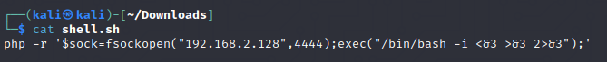

The shell script can then be executed and captured using a Netcat listener.



1. Scanning the victim machine with an automatic script or manually checking common misconfigurations reveals that “/etc/passwd” is writable. Adding a new user to this file allows for privilege escalation.

Creating a password using OpenSSL.

Adding the new user and password to “/etc/passwd”.



Switching to the new “admin” user with the password “password” grants access to the root account.

1. Retrieve the flag from “/root/Flag.txt”.

